AI2002 – Artificial Intelligence
Quiz – 4B

Name
Roll. No.
Section

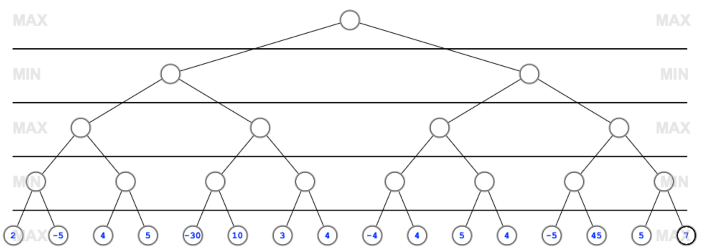

Solution



